|  |  |  |  |
| --- | --- | --- | --- |
|  | **Course Name: Advanced Web Technology** | **EXPERIMENT NO. 5** | |
| **Course Code: 20CP314P**  **Faculty: Komal Singh** | **Branch: CSE** | **Semester: VI** |
| **Submitted by: Patel Vraj ChetanKumar**  **Roll no: 21BCP362** | | | |

Objective: Create your first React code

Experiment 5:

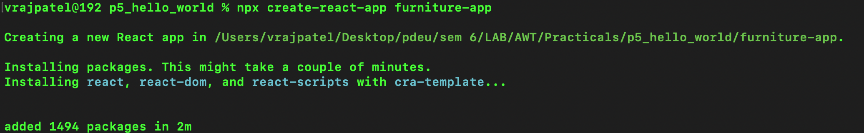Q1 Create a “hello world” react app.

Q2 Create a multiple web page commercial furniture application having a navigation bar using react components having pages such as home, products and customer review.

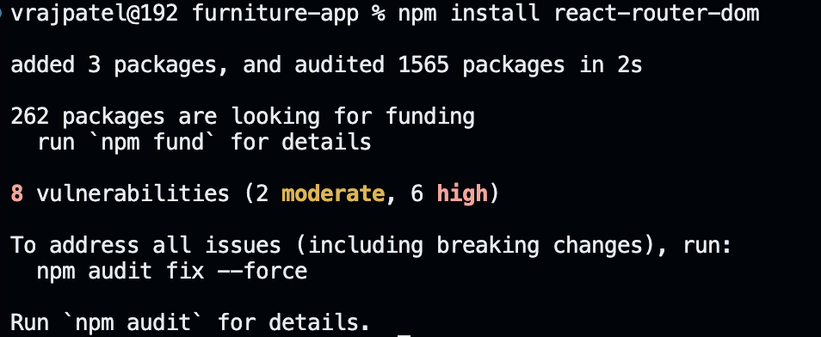

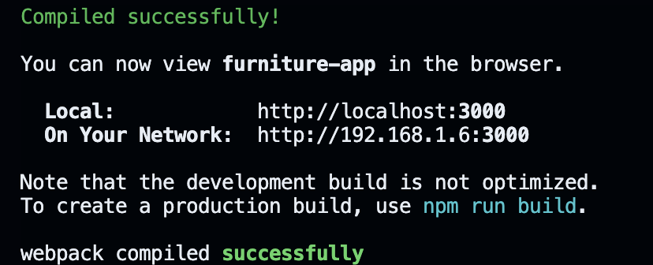

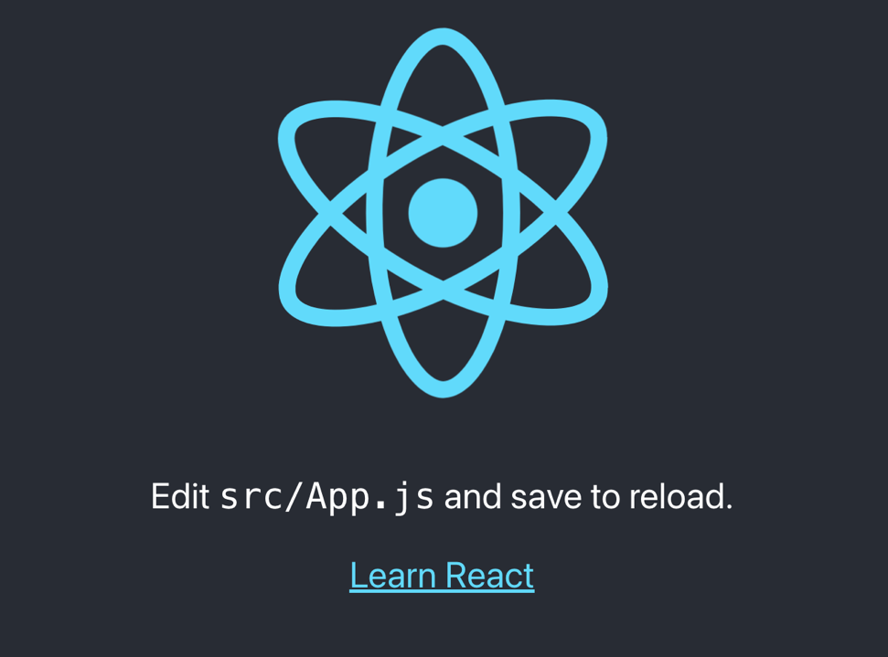

Q2 Create a multiple web page application having a navigation bar using react components having pages such as home, products and customer review.

**Steps**

1. **Create react app**
2. **Remove files that are not required**
3. **Create following files in src folder**
   1. **Home.js & Home.css**
   2. **Products.js & Products.css**
   3. **Blogs.js and so on**
4. **Update the App.js files with import**